
Sky Smart Technology (Pvt) Ltd.

Sustainability Web Application

ER Diagrams
For
Health and Safety Module

Version 1.0

Date Created: 09/04/2025
Created by: Chandima Samarakoon

Table of Contents
Hazard and Risk 3
Accident Management 3
Incident Management 4
Document 4
Occupational Health 4

Hazard and Risk
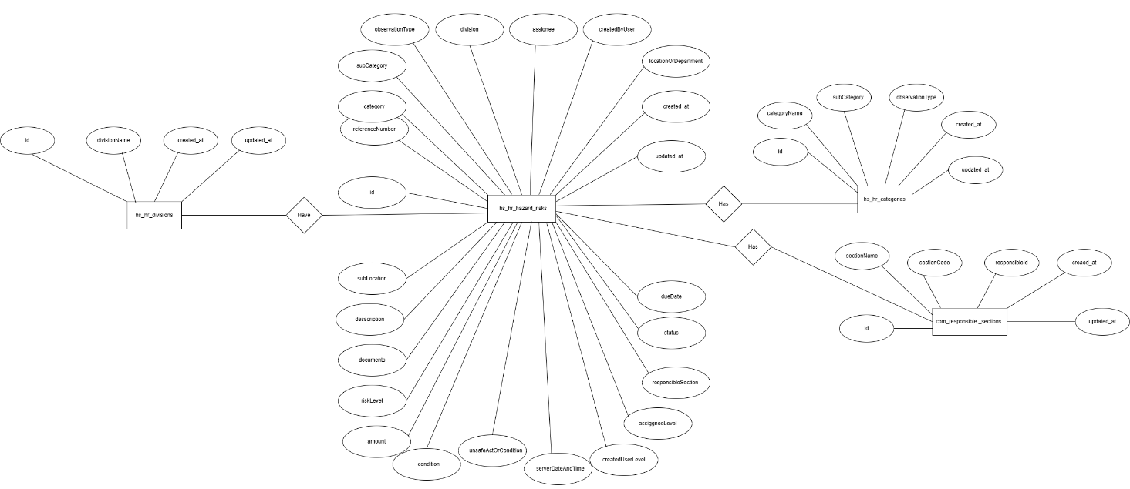

Accident Management
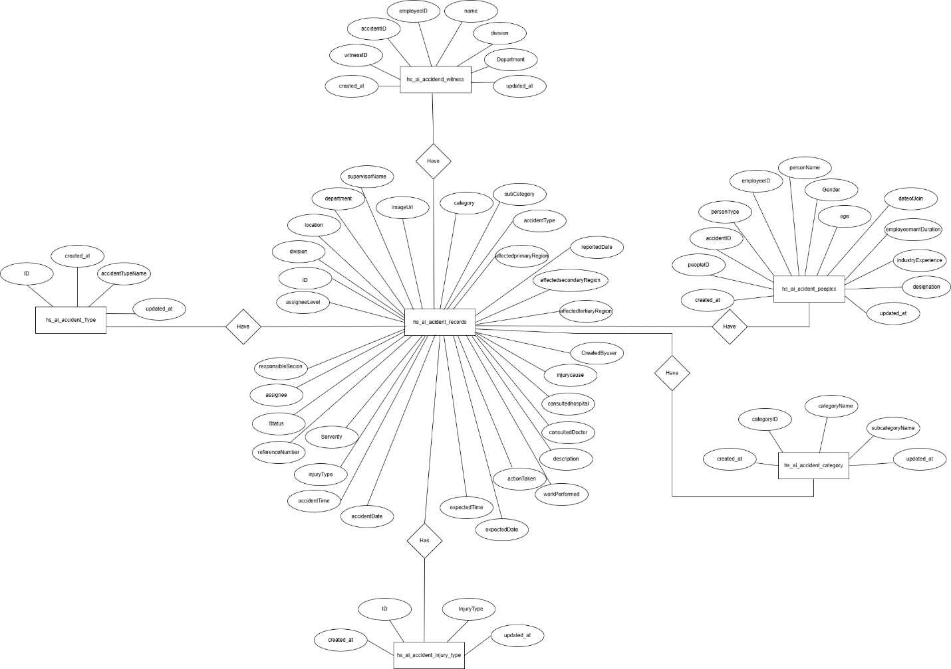

Incident Management
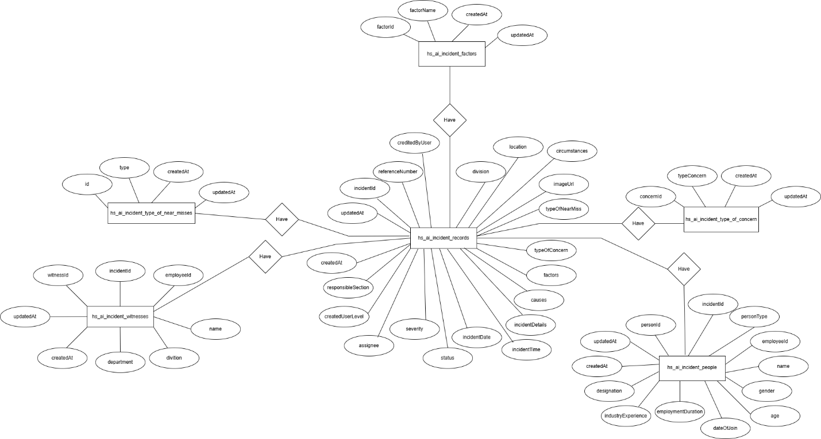

Document
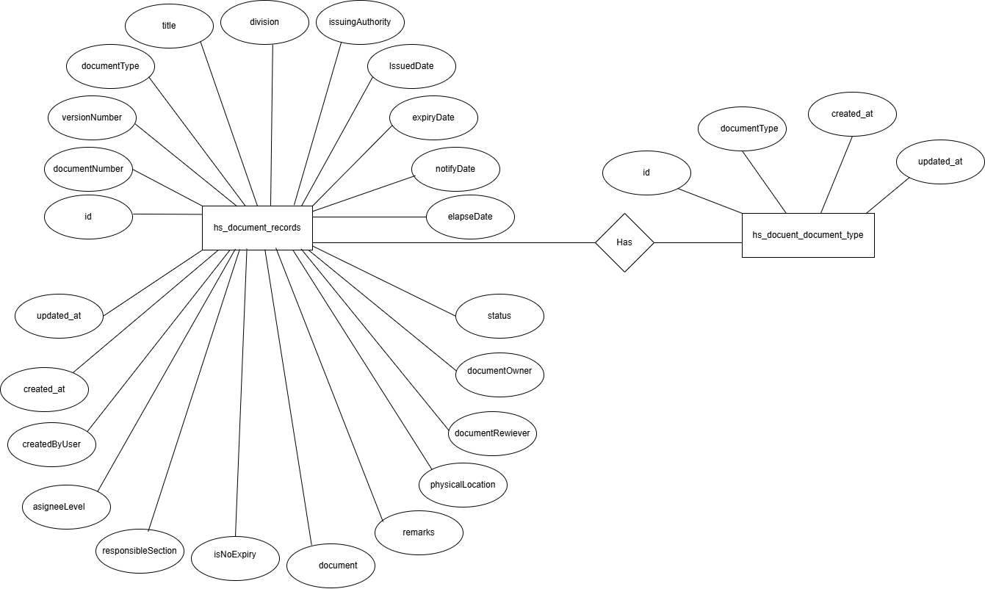

Occupational Health
